ToDo Lists Express JS

GIT HUB LINK :- https://github.com/ladganesh22-cloud/DoListExpressProject

How to works
- The server is built using Express.js.
- It listens on port 4000.
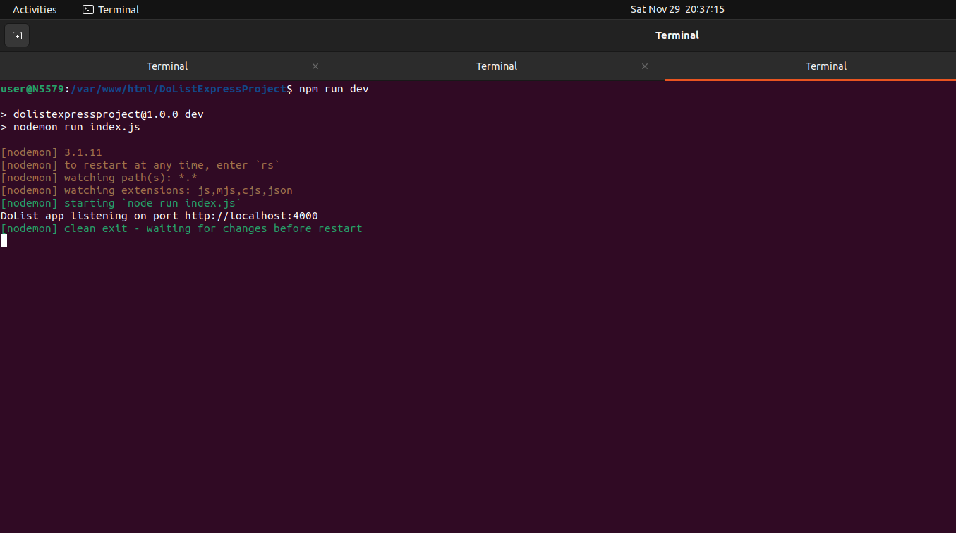

CURD Operations
Get API
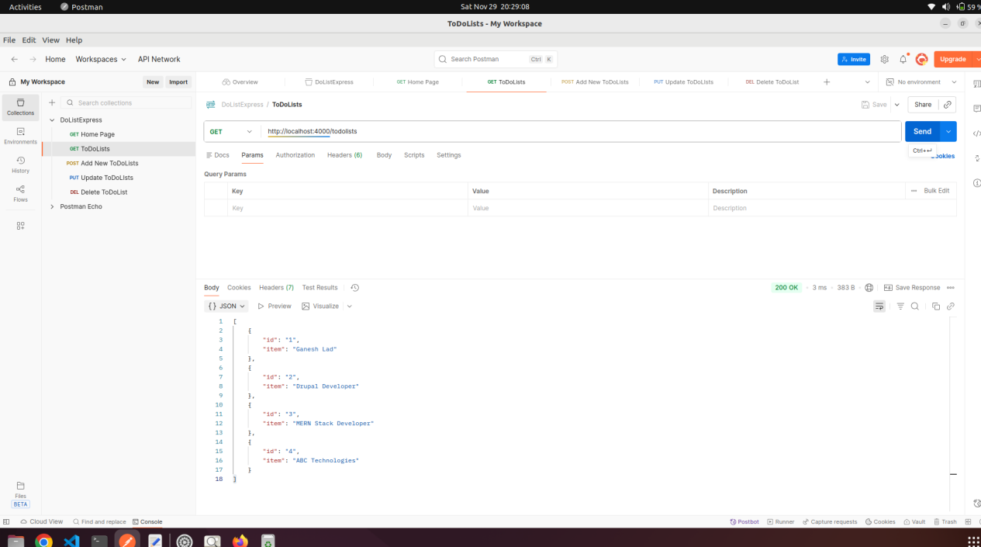

POST API
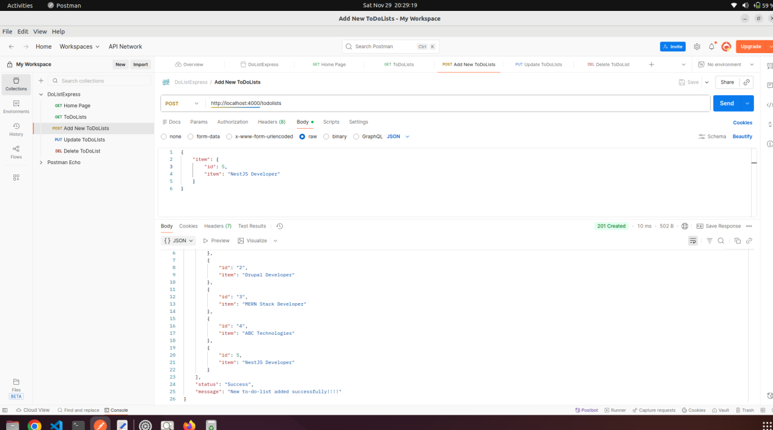

PUT API
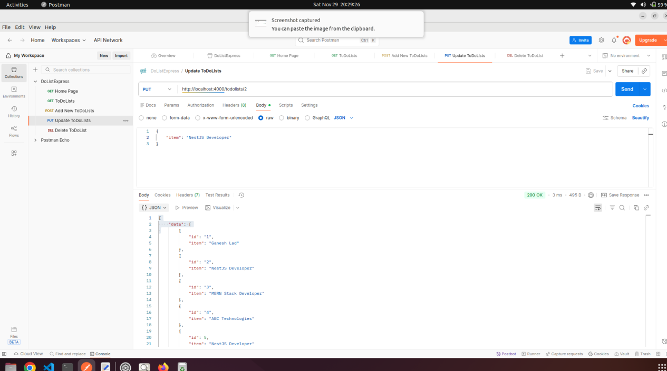

DELETE API
